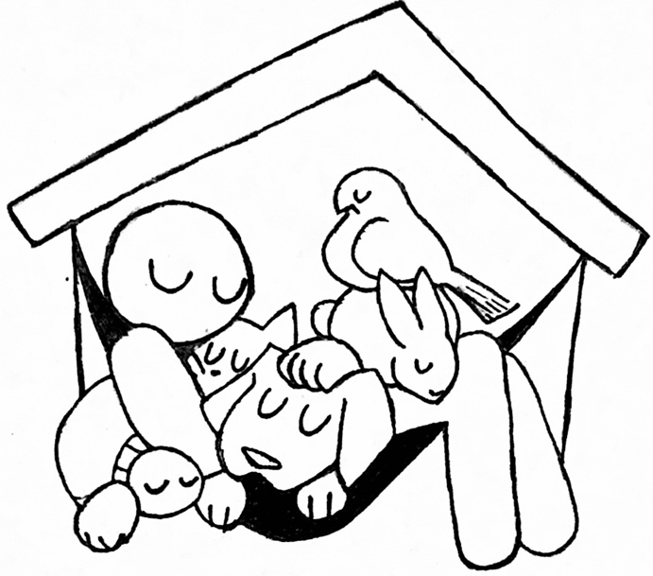Does your pup need a couple of hours of exercise? Does your job not allow you the ability to drop your pup off or pick them up in a way that’s convenient for you? Well, we have a solution for that. Here at Homeward Bound Pet Sanctuary, we offer pet sitting at an affordable price. Whether you need just a couple of hours or need something that surpasses what a traditional daycare offers? We’ve got you covered. With being available 24/7, we can offer pet parents to drop off or pick up their fur babies at any time, night or day. If it is difficult for you to drop them off, you can make arrangements for us to pick up your pet and drop them off when it’s convenient for you for an additional charge.

Pet Sitting